

**Trimester: I/II/III Subject:** Basic Mechanical Engineering

**Name**: Krishnaraj Thadesar **Division:** 9

**Roll No.:** 109054 **Batch:** I3

**Experiment No.:** 3

**Name of the Experiment:** Demonstration of various operations on a lathe machine

**Performed on:** 2nd September 2021

**Submitted on:** 9th September 2021

*Aim:*

To study the various operations such as turning, step turning, facing, boring, taper turning,  
knurling, grooving, threading of center lathe.

*Theory*:

A product is made up of many components which are manufactured by various manufacturing processes such as *casting, forging, welding; machining etc*. depends on the application and cost of that particular component.

In the machining process various operations *like turning, step turning, facing, boring, taper turning, knurling, grooving, threading* as used. All these operations can be done on *center lathe* hence center lathe is one of the important types of machines. In this practical we are going to study the operations which are mentioned above.

*Lathe*: is a machine tool which rotates the work piece on its axis to perform various operations such as cutting, sanding, knurling, drilling or deformation with tools that are applied to the work piece to create an object which has symmetry about an axis of rotation.

Examples of objects that can be produced on a lathe include candlestick holders, gun barrels, sticks, table legs, bowls, baseball bats, musical instruments (especially woodwind instruments), crankshafts and camshafts.

*Lathe Operations:*

The working of the lathe machine changes with every operation and cut desired. There are a lot of operations used for using the lathe machine.

Lathe machines create sophisticated parts for medical, military, electronics, automotive, and aerospace applications A lathe is capable of performing numerous machining operations to deliver parts with the desired features.

*The variation of tool ends and a kinematic relation between the tool and workpiece results in different operations on a lathe*. Some of which are explained below.

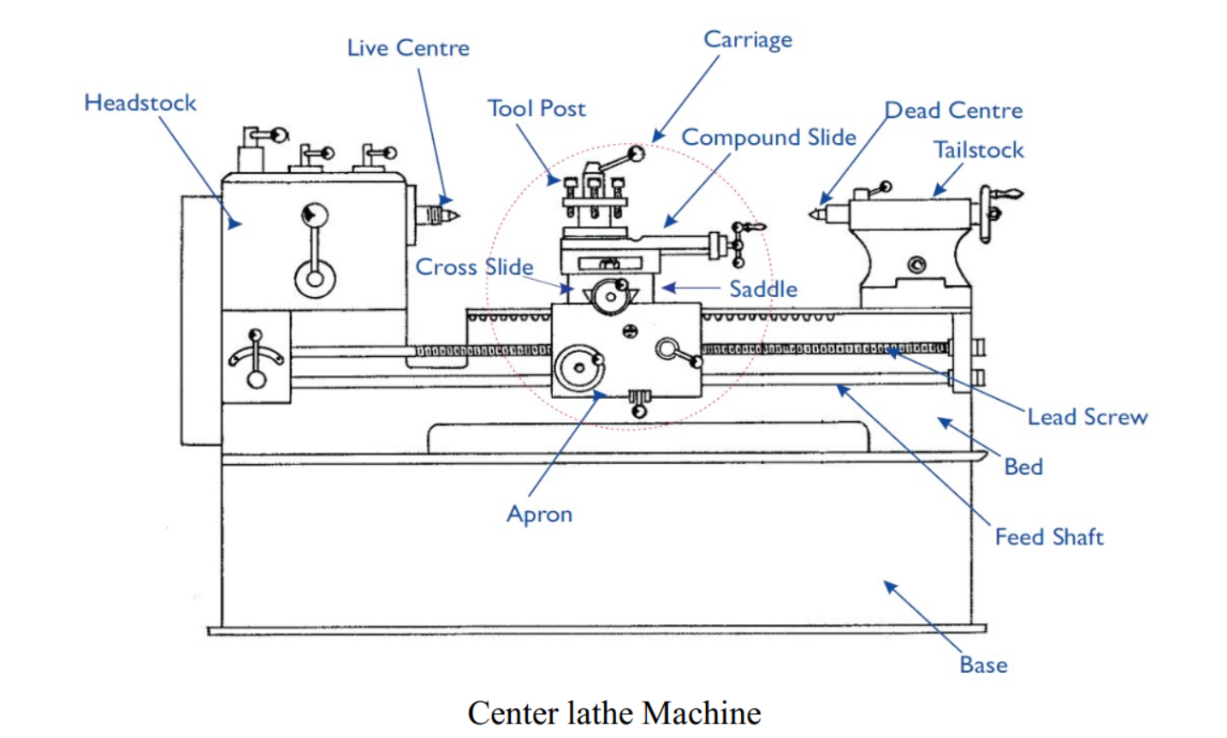

*Various Lathe Operations*

1. ***Turning:*** This is the basic operation of lathe machines to produce cylindrical surfaces. The tool is fed parallel to the rotating work axis to create cylindrical surfaces.
2. ***Facing:*** The tool is fed radially into the rotating work on one end to create a flat surface.
3. ***Taper turning:*** Instead of feeding the tool parallel to the axis of rotation of the work, the tool is fed at an angle, thus creating a tapered cylinder or conical shape.
4. ***Chamfering:*** The cutting edge of the tool is used to cut an angle on the corner of the cylinder,  
   forming what is called a chamfer.
5. ***Drilling:*** Drilling can be performed on a lathe by feeding the drill into the rotating work along its  
   axis. Reaming can be performed in a similar way.
6. ***Knurling:*** This is not a machining operation because it does not involve cutting of material.  
   Instead, it is a metal forming operation used to produce a regular crosshatched pattern in the work  
   surface.

*Various Lathe Operations*

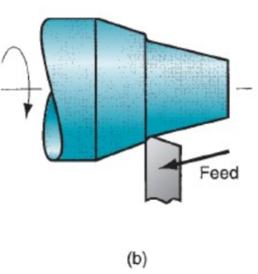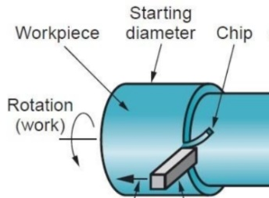

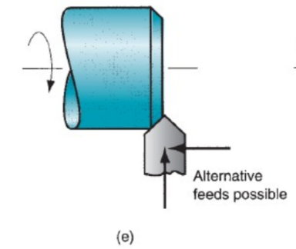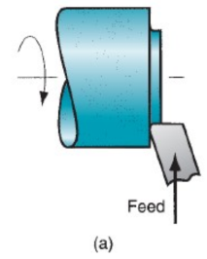

2.Facing

4.Chamfering

3.Taper Turning

1.Turning

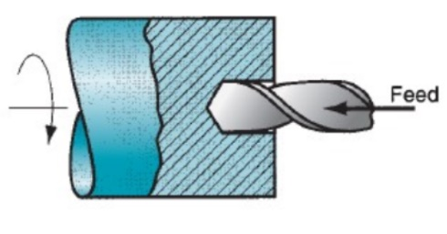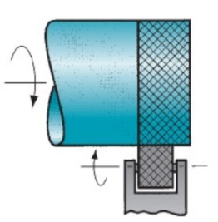

6.Knurling

5.Drilling

*Components of a Lathe machine and their functions:*

1. *Bed*: Almost all lathes have a horizontal beam is called as bed. It has guide ways on it for sliding and  
   supporting tail stock and carriage.
2. *Head Stock*: At one end of the bed (almost always the left, as the operator faces the lathe) is a  
   headstock. It contains drive mechanism with necessary speed change arrangement to achieve  
   different speeds. It also has chuck which is used to hold the job.
3. *Tail Stock*: It is placed opposite to headstock. It can move along guide ways. Its main applications  
   are to hold long jobs to avoid vibrations and excessive deformation and for drilling axial holes in the  
   work piece it can also hold the tools such as drill, reamer, tap to do the operations like drilling,  
   reaming etc.
4. *Carriage*: It is located between headstock and tailstock. It can be moved in a longitudinal direction  
   and can be fixed at any position. Carriage has following parts
5. *Saddle*: Its base portion, located across the lathe bed and carries cross slide and tool post, it can be moved longitudinally along the bed.
6. *Apron*: it is attached to the saddle and appears as hanging on the front side. It consists of gears for motion transmission.
7. *Cross Slide*: it is mounted on top of the saddle and acts as support to compound rest
8. *Compound Rest*: It is mounted on a cross slide and it consists of swivel and top slide. The tool  
   post is mounted on the top slide.
9. *Tool-Post*: it is used to hold the tool position the tool as per the requirement

*Conclusion*:

The components, working and applications of the Lathe Machine were studied.

Lathe is a machine which rotates the work piece on its axis to perform various operations such as cutting, sanding, knurling, et cetera with tools that are applied to the work piece to create an object which has symmetry about an axis of rotation.

The Major operations on the Lathe machine were studied and understood. Operations *like Turning, Facing, Chamfering, Taper Turning, Drilling, and Knurling* were studied in detail.

*Questions:*

1. List out the types of lathe.
   1. Following are the seven different types of lathe machine:
2. Speed Lathe Machine
3. Centre Lathe Machine
4. Bench Lathe Machine
5. Toolroom Lathe Machine
6. Capstan and Turret Lathe Machine
7. Special purpose lathe machines
8. Automatic Lathe Machine
9. How is the size of a lathe specified?
   1. Lathe size, also known as its work envelope, is *the dimension of the largest cylinder that can be machined on it.* Two main dimensions frequently included in lathe model code in inches or hundreds of millimeters.
      1. The distance between the chuck and tailstock point (maximal detail length)
      2. max diameter of detail (a) over lathe bed and (b) over carriage (or spindle axes height)
10. What are different components mounted on the carriage of a lathe? Explain any two.
    1. *Carriage*: It is located between headstock and tailstock. It can be moved in a longitudinal direction  
       and can be fixed at any position. Carriage has following parts.
11. *Saddle*: Its base portion, located across the lathe bed and carries cross slide and tool post, it can be moved longitudinally along the bed.
12. *Cross Slide*: it is mounted on top of the saddle and acts as support to compound rest